IoT-Based Weather Station Using ESP32 and Cloud Dashboard
Project Report — Industrial Training Program on Robotics and AI

1. Problem Statement
This project designs and implements an IoT-based weather monitoring system built around an ESP32 microcontroller. The system:
- Reads temperature and humidity using a DHT22 sensor.
- Sends sensor data to the ThingSpeak cloud platform over the ESP32's built-in Wi-Fi.
- Displays live graphs of temperature and humidity on a ThingSpeak channel dashboard.
- Triggers an email alert whenever temperature or humidity crosses a predefined threshold.

2. System Architecture (Question 1)
The figure below shows the end-to-end data flow. The DHT22 sensor is wired to a GPIO pin on the ESP32. The ESP32 firmware polls the sensor at a fixed interval, connects to the local Wi-Fi network, and pushes each reading to a ThingSpeak channel over HTTP using a REST API write key. ThingSpeak stores the values as two channel fields (Field 1 = Temperature, Field 2 = Humidity) and renders them as live line graphs. A ThingHTTP / IFTTT Webhooks action, triggered either by a ThingSpeak React rule or directly by the firmware, sends an email whenever a value goes outside the safe range.
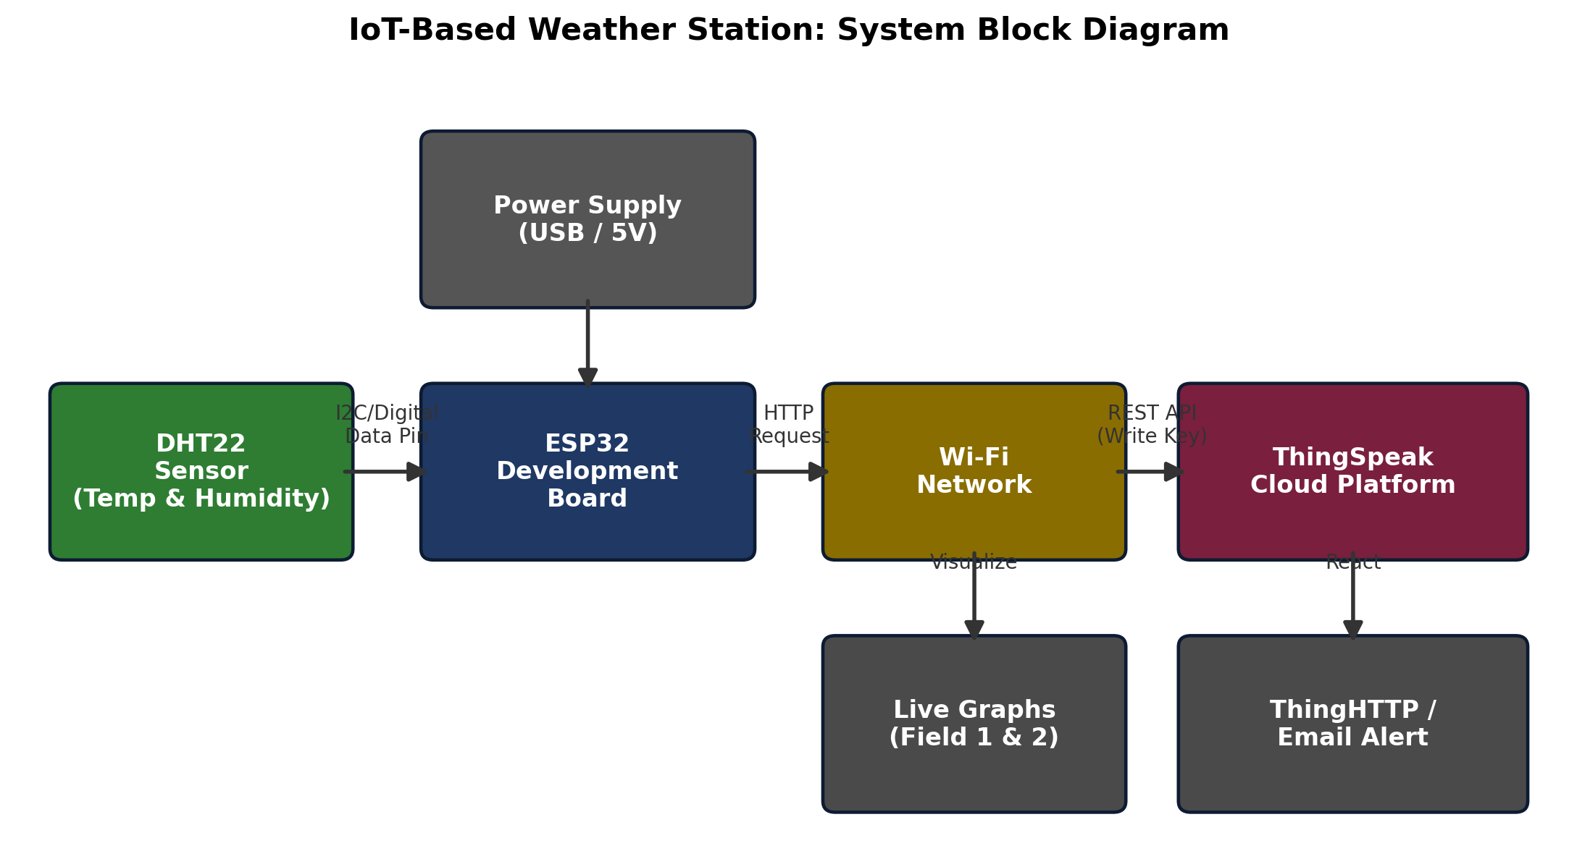
Figure 1: Block diagram of the IoT weather station

Signal / data path
- DHT22 -> ESP32: single-wire digital data line (GPIO 4), sensor powered from 3.3 V.
- ESP32 -> Wi-Fi router: 2.4 GHz WPA2 station connection.
- ESP32 -> ThingSpeak: HTTPS/HTTP GET request to the Update API with the channel write key and two field values.
- ThingSpeak -> Browser: channel's public/private view renders Field 1 and Field 2 as auto-updating charts.
- ThingSpeak/ESP32 -> IFTTT Webhooks -> Email: alert path used for threshold notifications.

3. Sensor Interfacing Firmware (Question 2)
The DHT22 is read using the Adafruit DHT library, which handles the single-wire timing protocol. The core routine below returns both readings and validates them, since the DHT22 occasionally returns NaN on a noisy read:
#define DHT_PIN 4
#define DHT_TYPE DHT22
DHT dht(DHT_PIN, DHT_TYPE);

bool readSensor(float &temperature, float &humidity) {
temperature = dht.readTemperature(); // Celsius
humidity = dht.readHumidity(); // % RH
if (isnan(temperature) || isnan(humidity)) {
Serial.println("ERROR: Failed to read DHT22!");
return false;
}
return true;
}

Full firmware is provided in the accompanying source file weather_station.ino.

4. Cloud Data Upload (Question 3)
Every UPLOAD_INTERVAL (20 seconds, respecting ThingSpeak's free-tier 15-second minimum), the firmware builds an HTTP GET request to the ThingSpeak Update API, embedding the write API key and the two field values:
String url = String(TS_SERVER) + "?api_key=" + TS_API_KEY +
"&field1=" + String(temperature, 2) +
"&field2=" + String(humidity, 2);
http.begin(url);
int httpCode = http.GET();

Verifying the upload
- ThingSpeak's GET response body is the new entry ID as an integer; a value of 0 means the update was rejected (e.g. rate-limited or wrong key).
- The Arduino IDE Serial Monitor (115200 baud) prints each reading and the returned entry ID for quick verification.
- The channel's "Private View" > "Data Import/Export" tab lists every logged entry with a timestamp, confirming both fields update correctly.

5. Data Visualization (Question 4)
On ThingSpeak, create a channel with two fields: Field 1 = Temperature (°C) and Field 2 = Humidity (%RH). Steps to configure live graphs:
- Sign in to thingspeak.com and select New Channel.
- Enable Field 1 and Field 2, name them Temperature and Humidity, and save the channel.
- Copy the channel's Write API Key into TS_API_KEY in the firmware.
- Open the channel's Private View — ThingSpeak automatically generates a line-chart widget per field, updating as new entries arrive.
- Optional: use Matlab Visualizations or a Gauge widget in ThingSpeak Apps for a dashboard-style display, and resize/drag widgets on the Public View for the final dashboard layout.

6. Alert Mechanism (Question 5)
Two implementation options were considered:
- Option A — ThingSpeak React + ThingHTTP + Email: a ThingSpeak "React" rule watches Field 1/Field 2 and, when a condition (e.g. Field1 > 38) is true, runs a ThingHTTP action that calls an email service.
- Option B — ESP32-side check + IFTTT Webhooks (used in the provided firmware): the ESP32 evaluates the threshold locally right after each reading and, if crossed, POSTs to an IFTTT Webhooks event, which is configured with an "Email" action (via IFTTT's Gmail/Email service).
Option B was implemented because it reacts immediately (no dependency on ThingSpeak's polling interval) and keeps the alert logic transparent in the firmware:
bool tempAlert = (temperature > TEMP_HIGH_THRESHOLD) ||
(temperature < TEMP_LOW_THRESHOLD);
bool humAlert = (humidity > HUM_HIGH_THRESHOLD) ||
(humidity < HUM_LOW_THRESHOLD);

if ((tempAlert || humAlert) &&
(millis() - lastAlertTime >= ALERT_COOLDOWN)) {
// POST to IFTTT Webhooks -> triggers email
}

IFTTT setup
- Create an applet: If Webhooks (event name weather_alert) Then Email (or Gmail).
- Copy the personal Webhooks key from ifttt.com/maker_webhooks/settings into IFTTT_KEY.
- An ALERT_COOLDOWN (5 minutes) prevents inbox flooding while a threshold remains crossed.

7. Tools Used
- ESP32 Development Board
- DHT22 Temperature & Humidity Sensor
- Arduino IDE / PlatformIO
- ThingSpeak Cloud Platform
- IFTTT Webhooks (email alert delivery)

8. Submission Checklist
- Project Report (this PDF)
- Source Code — weather_station.ino
- Screenshots of ThingSpeak dashboard and triggered alerts
Folder name for Google Drive submission: IoT_Weather_Station_<StudentName>

